Project Design Phase
Solution Architecture
Date | 20 July 2026
Team ID
Project Name | ShopEZ :E-commerce Application
Team Members | Vamsi Krishna Sinisetti, Allam Devi Mounika, Reddy Venkata Surya Chakra Mahalakshmi, Dhullipalla Radhika, Vijendra Kumar Mummidi
Maximum Marks | 4 Marks
Solution Architecture
Solution architecture is a complex process — with many sub-processes — that bridges the gap between business problems and technology solutions. Its goals are to:
- Find the best tech solution to solve existing business problems.
- Describe the structure, characteristics, behavior, and other aspects of the software to project stakeholders.
- Define features, development phases, and solution requirements.
- Provide specifications according to which the solution is defined, managed, and delivered.
ShopEZ – Solution Architecture Diagram
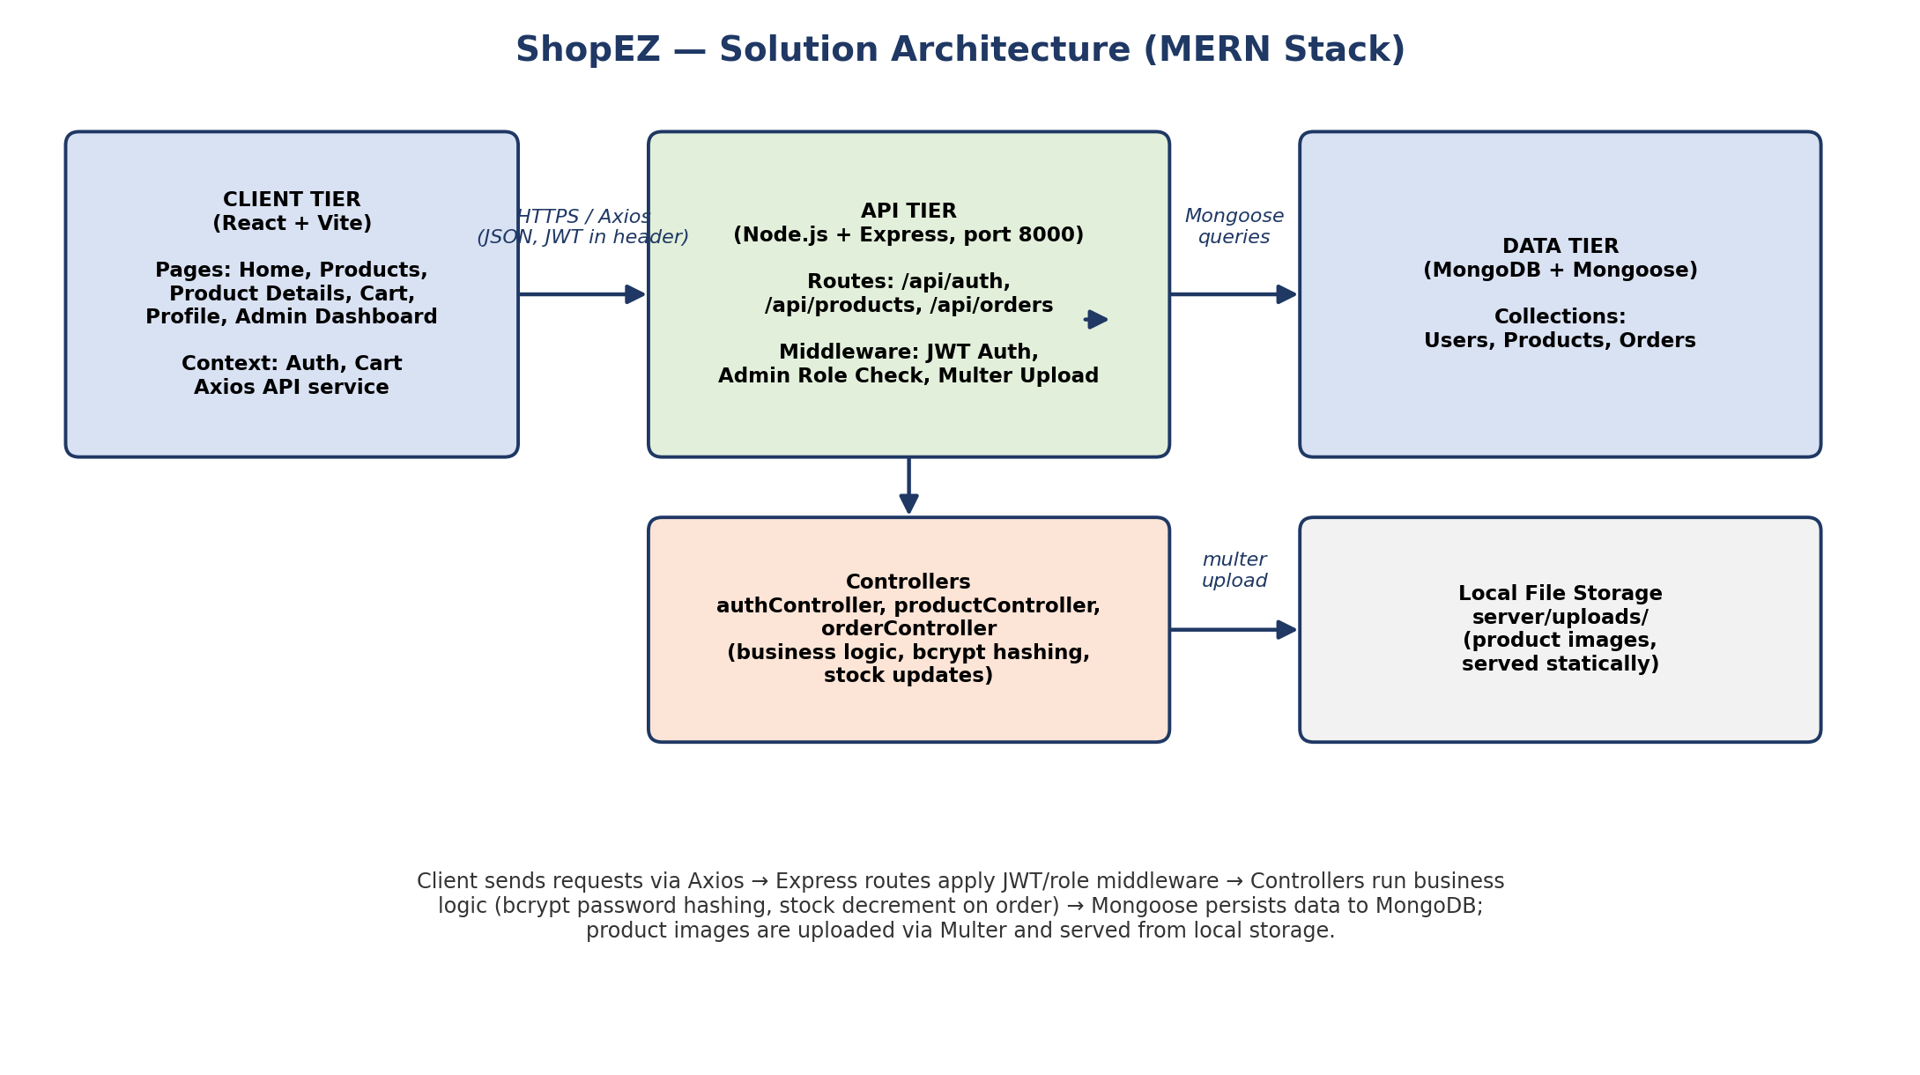
Figure 1: Architecture and data flow of the ShopEZ MERN-stack e-commerce application
Architecture Layers
Layer | Description
Client Tier | React (Vite) single-page app. Pages: Home, Products, Product Details, Cart, Profile, Admin Dashboard, Login/Register. AuthContext and CartContext manage session and cart state; Axios service layer calls the REST API.
API Tier | Node.js + Express REST API (port 8000) exposing /api/auth, /api/products, and /api/orders routes. JWT authentication middleware and an admin role-check middleware protect private/admin routes; Multer handles product image uploads.
Business Logic | authController, productController, and orderController implement registration/login (bcrypt password hashing, JWT issuance), CRUD for products, and order placement including automatic stock decrement.
Data Tier | MongoDB accessed via Mongoose ODM. Collections: Users (credentials, role), Products (details, price, stock), Orders (items, status, totals).
File Storage | Uploaded product images are stored in server/uploads/ and served as static files at /uploads/<filename>.

